PATIENT SATISFACTION WITH GREEN INITIATIVES IN MALAYSIAN HOSPITAL

SAFWAN BIN OTHMAN

Choose an item.

UNIVERSITI SULTAN ZAINAL ABIDIN

2023



PATIENT SATISFACTION WITH GREEN INITIATIVES IN MALAYSIAN HOSPITAL

SAFWAN BIN OTHMAN

Choose an item. submitted in the fulfillment of the requirement for the degree of Choose an item. in the

Choose an item.

Universiti Sultan Zainal Abidin

2023

ABSTRAK

KEPUASAN PESAKIT KE ARAH INISIATIF HIJAU DALAM HOSPITAL DI MALAYSIA

Isu alam sekitar merupakan salah satu masalah yang kritikal melanda dunia. Memandangkan industri perhotelan berkait rapat dengan alam sekitar secara langsung, pihak hotel perlu mengambil inisiatif bagi mengurangkan impak negatif kepada alam sekitar. Kajian ini dijalankan bagi mengkaji persepsi pelanggan terhadap inisiatif hijau, iaitu amalan hijau dan imej hijau sesebuah hotel dan kesannya kepada kepuasan dan kesetiaan mereka terhadap hotel tersebut. Dalam kajian ini, amalan hijau dan imej hijau berperanan sebagai pemboleh ubah tidak bersandar, manakala kesetiaan pelanggan berperanan sebagai pemboleh ubah bersandar. Kepuasan pelanggan dikenal pasti sebagai faktor penengah ke atas hubungan antara amalan hijau dan imej hijau terhadap kesetiaan pelanggan. Kajian ini menggunakan kaedah kuantitatif dan disokong dengan kaedah kualitatif. Melalui kaedah kuantitatif, soal selidik diedarkan secara bersemuka kepada responden. Daripada keseluruhan soal selidik yang dikumpul, sebanyak 300 responden telah dipilih menggunakan kaedah persampelan rawak mudah dan dianalisis menggunakan perisian SPSS dan AMOS. Bagi memantapkan dan mendalami hasil dapatan analisis kuantitatif ini, penyelidik mengumpul data melalui kaedah kualitatif iaitu perbincangan kumpulan fokus dan temubual. Seramai 11 orang responden terlibat dalam perbincangan kumpulan fokus dan tiga orang responden lain dipilih untuk ditemubual. Hasil daripada analisis inferensi seperti ujian T dan ANOVA menunjukkan faktor demografi terpilih iaitu jantina, umur, bangsa, tahap pendidikan, kekerapan menginap di hotel tersebut, penarafan bintang hotel dan kewarganegaraan tidak memberi perbezaan kepada tahap kesetiaan pelanggan terhadap hotel yang didiami. Berdasarkan pemodelan persamaan berstruktur, kajian mendapati imej hijau mempunyai hubungan yang signifikan dengan kepuasan pelanggan dan kesetiaan pelanggan. Selain itu, kepuasan pelanggan juga bertindak sebagai mediator dalam hubungan antara imej hijau dan kesetiaan pelanggan. Walaupun amalan hijau mempunyai hubungan yang signifikan dengan kepuasan pelanggan dan kesetiaan pelanggan, namun hubungan negatif wujud antara amalan hijau dan kepuasan pelanggan. Kepuasan pelanggan juga bertindak sebagai mediator dalam hubungan antara amalan hijau dan kesetiaan pelanggan. Hasil perbincangan kumpulan fokus dan temubual menunjukkan sembilan faktor yang menyebabkan pelanggan tidak berpuas hati dengan hotel yang mengadaptasi amalan hijau, iaitu pelanggan kurang kesedaran tentang isu alam sekitar, kesedaran yang rendah tentang masalah alam sekitar dalam kalangan pengusaha hotel, harga bilik, sikap pelanggan, pengurusan hotel lebih fokus terhadap operasi dan belum bersedia untuk mempraktikkan amalan hijau, kemudahan yang disediakan tidak setanding dengan harga yang dibayar dan keperluan pelanggan

ABSTRACT

PATIENT SATISFACTION WITH GREEN INITIATIVES IN MALAYSIAN HOSPITAL

Environmental issues are among the critical problems plaguing the world. Since the hotel industry is closely and directly related to the environment, hotels should take initiatives to reduce any negative impact on the environment. This study was conducted to examine customer perceptions of green initiatives; namely, concerning the green practices and the green image of a hotel, and how these impact their satisfaction and loyalty to the hotel. In this study, green practices and green image act as the independent variables, while customer loyalty acts as the dependent variable. Customer satisfaction has been identified as the mediating factor on the relationship of green practices and green image with customer loyalty. This study used quantitative method and supported with qualitative method. For the quantitative method, questionnaires were distributed to respondents face-to-face. From the questionnaires collected, 300 respondents were selected using a random sampling method and analyzed using SPSS and AMOS. To strengthen and explore in depth the results obtained through this quantitative analysis, the researchers collected data through qualitative methods by means of focus group discussions and interviews. A total of 11 respondents were involved in the focus group discussions, and three respondents were chosen to be interviewed. The results of the inference analysis, such as T-test and ANOVA, showed that selected demographic factors, such as gender, age, race, education level, frequency of staying in the hotel, hotel star rating and citizenship, did not make a difference to the levels of customer loyalty to the hotel occupied. Based on structural equation modeling, the study found that green image has a significant relationship with customer satisfaction and customer loyalty. In addition, customer satisfaction also acts as a mediator in the relationship between green image and customer loyalty. Although green practices have a significant relationship with customer satisfaction and customer loyalty, there is a negative relationship between green practices and customer satisfaction. Customer satisfaction also acts as a mediator in the relationship between green practices and customer loyalty.

ACKNOWLEDGEMENT

First and above all, I praise to Allah, the Almighty for providing me this opportunity and granting me the capability to proceed successfully. This thesis appears in its current form due to the assistance and guidance of several people. I would therefore like to offer my sincere thanks to all of them.

Firstly, I would like to express my sincere gratitude to my main supervisor …… for accepting me as a PhD student, continuous support for my study and related research, for his patience, motivation, thoughtful guidance, critical comment and immense knowledge. His guidance helped me throughout the research and writing of this thesis. I could not have imagined having a better advisor and mentor for my PhD study.

I want to express my deep thanks to …… for his insightful comments and constructive suggestions not only concerning the structure and wording but also the content of the thesis with his professional experience and extensive knowledge of research methodology, especially in ………………..

Last but not least, my appreciation also extends to my colleagues and friends for being my friends and giving me moral support throughout this journey.

APPROVAL

I certify that an Examination Committee has met on (viva date) to conduct the final examination of (candidate’s name), on his / her thesis entitled ‘Title of Thesis’ in accordance with the regulations approved by the Senate of Universiti Sultan Zainal Abidin. The Committee recommends that the candidate be awarded the relevant degree, and it has been accepted by the Senate of Universiti Sultan Zainal Abidin as fulfilment of the requirements for the (insert the name of the degree). The members of the Examination Committee are as follows:

Mohamed Anuar Zamani, PhD

Professor

Name of Faculty

Universiti Sultan Zainal Abidin

(Chairperson)

Fakhrul Aysar Mamat, PhD

Associate Professor

Name of Faculty

Universiti Sultan Zainal Abidin

(Internal Examiner)

Name of External Examiner, PhD

Title (e.g., Professor / Associate Professor / Ir.; omit if irrelevant)

Name of Faculty

Name of University

(External Examiner)

|  |  |
| --- | --- |
|  | KHAMSAH SURYATI BINTI MOHD, PhD  Associate Professor Ts.  Dean of Graduate School  Universiti Sultan Zainal Abidin  Date: |

DECLARATION BY CANDIDATE

I hereby declare that the thesis is based on my original work except for quotations and citations, which have been duly acknowledged. I also declare that it has not been previously or concurrently submitted for any other degree at Universiti Sultan Zainal Abidin or other institutions.

|  |  |
| --- | --- |
|  | Name of Candidate: (Candidate name)  Date : (XX/XX/2023) |

DECLARATION BY Choose an item.

This is to confirm that:

The research conducted and the writing of this Choose an item. was under Choose an item. supervision.

|  |  |  |
| --- | --- | --- |
| Signature | : |  |
|  |
| Name of Main Supervisor | : |  |
| Faculty | : |  |

|  |  |  |
| --- | --- | --- |
| Signature | : |  |
|  |
| Name of Co-Supervisor | : |  |
| Faculty | : |  |

|  |  |  |
| --- | --- | --- |
| Signature | : |  |
|  |
| Name of Co-Supervisor | : |  |
| Faculty | : |  |

|  |  |  |
| --- | --- | --- |
| Signature | : |  |
|  |
| Name of Co-Supervisor | : |  |
| Faculty | : |  |

* Please remove unnecessary column, refer thesis writing guideline book.

TABLE OF CONTENTS

Page

ABSTRAK i

ABSTRACT i

ACKNOWLEDGEMENT i

APPROVAL i

DECLARATION BY CANDIDATE i

DECLARATION BY Choose an item. i

TABLE OF CONTENTS i

LIST OF TABLES i

LIST OF FIGURES i

LIST OF APPENDICES i

LIST OF ABBREVIATIONS i

LIST OF SYMBOLS i

LIST OF CASES i

LIST OF STATUTES i

LIST OF NOTATIONS i

GLOSSARY OF TERMS i

CHAPTER 1 INTRODUCTION 1

1.1 Research Background 1

1.2 MZJ Formatting Method 1

1.3 Problem Statement 1

1.4 Research Objectives 1

1.5 Research Limitation and Sample Size. 1

1.6 Research Questions 1

CHAPTER 2 LITERATURE REVIEW 1

2.1 Introduction 1

2.2 Sample Of Equation Is Here 1

2.2.1 Literature 2 1

2.3 Literature 3 1

2.3.1 Video Provides A Powerful Way To Help You Prove Your Point. 1

2.3.2 When you click Online Video, you can paste in the embed code for the video you want to add. 1

2.3.3 You can also type a keyword to search online for the video that best fits your document. 1

2.4 To make your document look professionally produced, Word provides header, footer, cover page, and text box designs that complement each other. 1

2.4.1 For example, you can add a matching cover page, header, and sidebar. 1

2.4.2 Click Insert and then choose the elements you want from the different galleries. 1

2.5 Save Time In Word With New Buttons That Show Up Where You Need Them. 1

2.6 Themes and styles also help keep your document coordinated. 1

2.7 You Can Collapse Parts Of The Document And Focus On The Text You Want. 1

2.7.2 Word remembers where you left off - even on another device. 1

2.8 Literature 2 1

2.8.1 Literature 3 1

2.8.2 Video provides a powerful way to help you prove your point. 1

2.8.2.1 When you click Online Video, you can paste in the embed code for the video you want to add. 1

2.8.2.2 You can also type a keyword to search online for the video that best fits your document. 1

2.8.2.3 To make your document look professionally produced, Word provides header, footer, cover page, and text box designs that complement each other. 1

CHAPTER 3 METHODOLOGY 1

3.1 Introduction 1

3.2 Video Provides A Powerful Way To Help You Prove Your Point. 1

3.2.1 When you click Online Video, you can paste in the embed code for the video you want to add. 1

3.2.2 You can also type a keyword to search online for the video that best fits your document. 1

3.2.2.1 To make your document look professionally produced, Word provides header, footer, cover page, and text box designs that complement each other. 1

3.2.2.2 For example, you can add a matching cover page, header, and sidebar. 1

3.2.3 Click Insert and then choose the elements you want from the different galleries. 1

3.3 MZJ Formatting Method 1

CHAPTER 4 RESULTS 1

4.1 Introduction 1

4.2 You Can Collapse Parts Of The Document And Focus On The Text You Want. 1

4.2.2 To make your document look professionally produced, Word provides header, footer, cover page, and text box designs that complement each other. For example, you can add a matching cover page, header, and sidebar. Click Insert and then choose the elements you want from the different galleries. 1

4.2.3 Reading is easier, too, in the new Reading view. You can collapse parts of the document and focus on the text you want. If you need to stop reading before you reach the end, Word remembers where you left off - even on another device. 1

CHAPTER 5 DISCUSSION 1

5.1 Introduction 1

5.1.1 Discussion based on objective number 1 1

5.1.2 Discussion based on objective number 2 1

5.1.3 Discussion based on objective number 3 1

5.2 Reading is easier, too, in the new Reading view. You can collapse parts of the document and focus on the text you want 1

5.3 Themes And Styles Also Help Keep Your Document Coordinated. 1

5.3.1 When you click Design and choose a new Theme, the pictures, charts, and SmartArt graphics change to match your new theme. 1

5.3.2 When you apply styles, your headings change to match the new theme. 1

5.4 Save time in Word with new buttons that show up where you need them. 1

5.5 To change the way a picture fits in your document, click it and a button for layout options appears next to it. 1

CHAPTER 6 CONCLUSION 1

6.1 Introduction 1

6.2 Highlight term 1 1

6.3 Highlight term 2 1

6.4 Highlight term 3 1

6.5 Conclusion 1

REFERENCES 1

APPENDICES 1

LIST OF PUBLICATION(S) 1

CANDIDATE BIODATA 1

LIST OF TABLES

|  |  |  |
| --- | --- | --- |
| Table No. | Title | Page |

Table 1.1 The number of hospital in Malaysia. 1

Table 2.1 Summary from the literature from literature from literature from literature from 1

Table 2.2 The Title for This Table is Here 1

Table 2.3 The Statistical Information of APM Dataset 1

Table 2.4 The Title for This Table is Here 1

Table 2.5 The Temperature Information 1

Table 2.6 The Environmental Dataset Information 1

Table 2.7 Summary of the Meteorological Parameters 1

Table 2.8 The Sample of the Table with More Than One Page Items 1

Table 4.1 Average rainfall in 2020. 1

Table 5.1 Humidity and wind speed in 2020. 1

LIST OF FIGURES

|  |  |  |
| --- | --- | --- |
| Figure No. | Title | Page |

Figure 1.1 Logo UniSZA (Ali et. Al, 2020) 1

Figure 1.2 A Sample of Formatting Method 1

Figure 1.3 The Hadith on Knowledge 1

Figure 1.4 Hospital UniSZA (ASO, 2020) 1

Figure 2.1 The Spectrum of Cooking Oil 1

Figure 2.2 A Sample of Grass and Bamboo 2 1

Figure 3.1 A Sample of Formatting Method 1

Figure 3.2 The Hadith on Knowledge 1

Figure 3.3 Landscape of the Hospital (SA, 2020) 1

Figure 3.4 The screen for formatting a thesis using MS Word (MZJ, 2017 1

Figure 4.1 Number of Covid-19 cases. 1

Figure 5.1 Covid-19 virus. 1

Figure 5.2 A PCA Plots for Data Processing Strategy 1

LIST OF APPENDICES

Page

Appendix A Example of the Codes in PLS Algorithms 1

Appendix B Table of Parameters Used in Data Processing for PLS Testing Precoders on the Classification of Biological Activity 1

Appendix C Table of Parameters 1

LIST OF ABBREVIATIONS

|  |  |
| --- | --- |
| UniSZA | Universiti Sultan Zainal Abidin |
| ACSI | American Customer Satisfaction Index |
| ATSP | Tourism Strategic Plan |
| C-SEM | Covariance Structure Analysis |
| MAB | Malaysia Airport Berhad |
| MLE | Maximum Likelihood Estimator |
| SD | Standard Deviation |
| TDC | Malaysia Tourism Corporation |
|  |  |
|  |  |
|  |  |
|  |  |
|  |  |
|  |  |
|  |  |
|  |  |
|  |  |
|  |  |
|  |  |
|  |  |
|  |  |
|  |  |
|  |  |

LIST OF SYMBOLS

|  |  |
| --- | --- |
| α | Alpha |
| β | Beta |
| π | Pi |
|  |  |
|  |  |
|  |  |
|  |  |
|  |  |
|  |  |
|  |  |
|  |  |
|  |  |
|  |  |
|  |  |
|  |  |
|  |  |
|  |  |
|  |  |
|  |  |
|  |  |
|  |  |
|  |  |
|  |  |

LIST OF CASES

Affin Bank Bhd v Zulkifli bin Abdullah [2006] 3 MLJ 67

Ainan Mahamud v Syed Abu Bakar & Ors [1938] 1 LNS 10

Albilt Resources Sdn Bhd v Casaria Construction Sdn Bhd [2010] 3 MLJ 656

Bank Islam Malaysia Bhd v Adnan bin Omar [1994] CLJ 735

Bank Kerjasama Rakyat v Emcee Corporation Sdn Bhd [2003] 2 MLJ 408

CMS Energy Sdn Bhd v Poscon Corp [2008] 6 MLJ 561

Danchevsky v Danshevsky [1975] 3 All ER 934

Goh Eng Hwa Construction v Macinta Sdn Bhd [1991] 1 CLJ 535

Jainah binti Semah v Mansor bin Iman Mat and Another [1951] 1 MLJ 62

Latifah Mat Zin v Rosmawati Sharibun & Anor [2007] 5 MLJ 101

Malayan Banking Bhd v Marilyn Ho Siok Lin [2006] 3 CLJ 796

Nafsiah v Abdul Majid [1969] 2 MLJ 174

Ramah v Laton [1927] 6 FMSLR 128

Re Timah binti Abdullah (decd) [1941] MLJ 51 Tyrrell v Painton [1895] 1 QB 202

Wee Chow Yong v Public Finance Bhd [1989] 3 MLJ 508

Yeoh Tat Beng v Keong Chiew [1957] MLJ 161

Zublin Muhibbah Joint Venture v Government of Malaysia [1990] 3 MLJ 125

LIST OF STATUTES

Administration of Islamic Enactment 2003 of Selangor

Administration of Islamic Religious Affairs Enactment 1993 of Penang

Administration of Muslim Law Enactment 1959 of Malacca

Arbitration Act 2005

Banking and Financial Institutions Act 1989

Bankruptcy Act 1967

Bills of Exchange Act 1949

Central Bank Act 2009

Civil Law Act 1956

Companies Act 1965

Contracts Act 1950

Courts of Judicature Act 196

LIST OF NOTATIONS

GLOSSARY OF TERMS

# INTRODUCTION

## Research Background

Video provides a powerful way to help you prove your point. When you click Online Video, you can paste in the embed code for the video you want to add. You can also type a keyword to search online for the video that best fits your document.



Figure ‎1.1 Logo UniSZA (Ali et. Al, 2020)

To make your document look professionally produced, Word provides header, footer, cover page, and text box designs that complement each other. For example, you can add a matching cover page, header, and sidebar. Click Insert and then choose the elements you want from the different galleries.

Themes and styles also help keep your document coordinated. When you click Design and choose a new Theme, the pictures, charts, and SmartArt graphics change to match your new theme. When you apply styles, your headings change to match the new theme. (Jaafar, 2010)

Table ‎1.1 The number of hospital in Malaysia.

|  |  |  |
| --- | --- | --- |
| Title | Title | Title |
| To change the overall look of your document | To change the overall look of your document | To change the overall look of your document |
| To change the overall look of your document | To change the overall look of your document | To change the overall look of your document |

Source: Malaysia Hospital report 2019

## MZJ Formatting Method

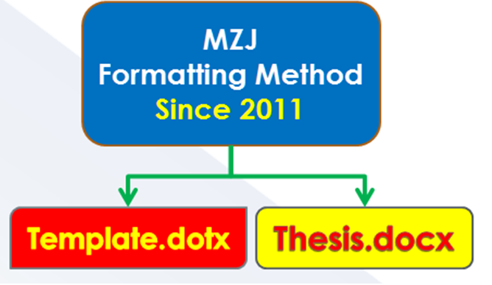

Figure ‎1.2 A Sample of Formatting Method

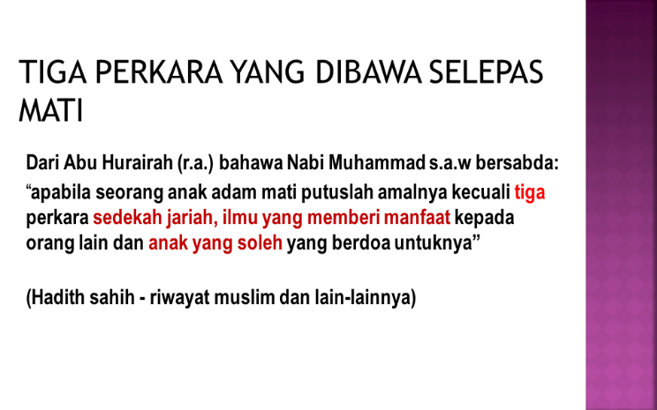

Figure ‎1.3 The Hadith on Knowledge

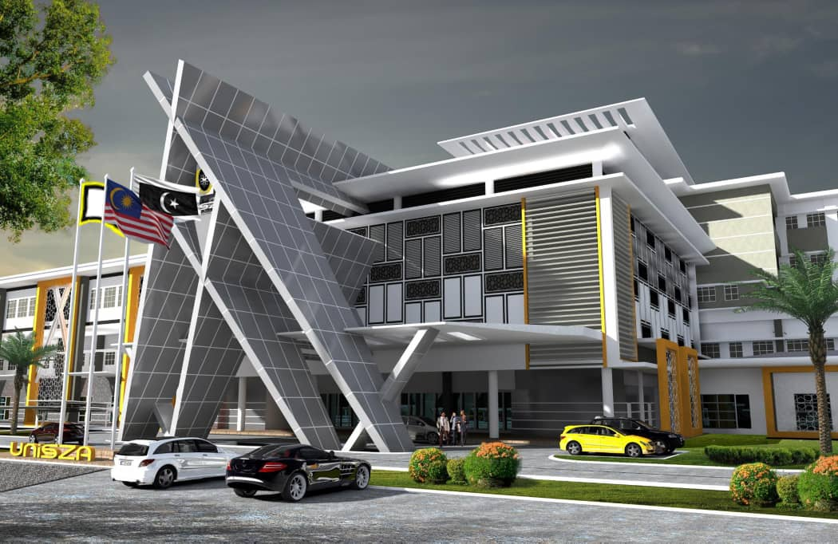

Figure ‎1.4 Hospital UniSZA (ASO, 2020)

## Problem Statement

Video provides a powerful way to help you prove your point. When you click Online Video, you can paste in the embed code for the video you want to add. You can also type a keyword to search online for the video that best fits your document.

To make your document look professionally produced, Word provides header, footer, cover page, and text box designs that complement each other. For example, you can add a matching cover page, header, and sidebar. Click Insert and then choose the elements you want from the different galleries.

###### Themes and styles also help keep your document coordinated. When you click Design and choose a new Theme, the pictures, charts, and SmartArt graphics change to match your new theme. When you apply styles, your headings change to match the new theme.

###### Themes and styles also help keep your document coordinated. When you click Design and choose a new Theme, the pictures, charts, and SmartArt graphics change to match your new theme. When you apply styles, your headings change to match the new theme.

###### Themes and styles also help keep your document coordinated. When you click Design and choose a new Theme, the pictures, charts, and SmartArt graphics change to match your new theme. When you apply styles, your headings change to match the new theme.

Video provides a powerful way to help you prove your point. When you click Online Video, you can paste in the embed code for the video you want to add. You can also type a keyword to search online for the video that best fits your document.

To make your document look professionally produced, Word provides header, footer, cover page, and text box designs that complement each other. For example, you can add a matching cover page, header, and sidebar. Click Insert and then choose the elements you want from the different galleries.

## Research Objectives

###### Video provides a powerful way to help you prove your point.

###### When you click Online Video, you can paste in the embed code for the video you want to add.

###### You can also type a keyword to search online for the video that best fits your document.

###### To make your document look professionally produced, Word provides header, footer, cover page, and text box designs that complement each other.

## Research Limitation and Sample Size.

Video provides a powerful way to help you prove your point. When you click Online Video, you can paste in the embed code for the video you want to add. You can also type a keyword to search online for the video that best fits your document.

To make your document look professionally produced, Word provides header, footer, cover page, and text box designs that complement each other. For example, you can add a matching cover page, header, and sidebar. Click Insert and then choose the elements you want from the different galleries.

Themes and styles also help keep your document coordinated. When you click Design and choose a new Theme, the pictures, charts, and SmartArt graphics change to match your new theme. When you apply styles, your headings change to match the new theme.

## Research Questions

###### Video provides a powerful way to help you prove your point.

###### When you click Online Video, you can paste in the embed code for the video you want to add.

###### You can also type a keyword to search online for the video that best fits your document.

###### To make your document look professionally produced, Word provides header, footer, cover page, and text box designs that complement each other.

###### For example, you can add a matching cover page, header, and sidebar.

# LITERATURE REVIEW

## Introduction

Video provides a powerful way to help you prove your point. When you click Online Video, you can paste in the embed code for the video you want to add. You can also type a keyword to search online for the video that best fits your document.[1]

Table ‎2.1 Summary from the literature from literature from literature from literature from

|  |  |  |  |  |
| --- | --- | --- | --- | --- |
| Title | Title | Title | Title | Title |
|  |  |  |  |  |
|  |  |  |  |  |
|  |  |  |  |  |
|  |  |  |  |  |

Source : Jabatan Perangkaan Malaysia, 2020

Table ‎2.2 The Title for This Table is Here

|  |  |  |
| --- | --- | --- |
| Title | Title | Title |
| To change the overall look of your document | To change the overall look of your document | To change the overall look of your document |
| To change the overall look of your document | To change the overall look of your document | To change the overall look of your document |
| Source: World Bank report 2016 | | |

Table ‎2.3 The Statistical Information of APM Dataset

|  |  |  |  |  |
| --- | --- | --- | --- | --- |
| Batch | No of samples | Average per month | Percentage of LoD (Coarse APM) | Percentage of LoD (Fine APM) |
| 1 | 100 | 8 samples | 1.70% | 6.48% |
| 2 | 102 | 9 samples | 9.29% | 9.09% |
| 3 | 176 | 9 samples | 2.65% | 4.34% |

Table ‎2.4 The Title for This Table is Here

|  |  |  |
| --- | --- | --- |
| Chemical C  Composition | Surface Area (m2g-1) | Porosity  (cm3g-1) |
| Neutral clay 0.68 0.68 | Neutral clay 0.68 0.68 | Neutral clay 0.68 0.68 |
| Bleaching clay | Bleaching clay | Bleaching clay |
|  |  |  |
| 0.80 | 0.89 | 0.99 |
| Note: Influence of the physical chemistry properties of an acid activated bentonite in the bleaching of olive oil. (Pradas et.al., 1993, p. 23) | | |

To make your document look professionally produced, Word provides header, footer, cover page, and text box designs that complement each other. For example, you can add a matching cover page, header, and sidebar. Click Insert and then choose the elements you want from the different galleries.[2]

Themes and styles also help keep your document coordinated. When you click Design and choose a new Theme, the pictures, charts, and SmartArt graphics change to match your new theme. When you apply styles, your headings change to match the new theme[3]

## Sample Of Equation Is Here

Themes and styles also help keep your document coordinated. When you click Design and choose a new Theme, the pictures, charts, and SmartArt graphics change to match your new theme. When you apply styles, your headings change to match the new theme as shown in (‎2.1). Equation (‎2.2) gives example on the use of word “Equation” in front of the equation numbering whenever a sentence starts with an equation.

On the Insert tab, the galleries include items that are designed to coordinate with the overall look of your document. You can use these galleries to insert tables, headers, footers, lists, cover pages, and other document building blocks. When you create pictures, charts, or diagrams, they also coordinate with your current document look. You can easily change the formatting of selected text in the document text by choosing a look for the selected text from the Quick Styles gallery on the Home tab. You can also format text directly by using the other controls on the Home tab.

|  |  |
| --- | --- |
|  | (‎2.1) |
|  | (‎2.2) |

#### Literature 2

To change the overall look of your document, choose new Theme elements on the Page Layout tab. To change the looks available in the Quick Style gallery, use the Change Current Quick Style Set command. Both the Themes gallery and the Quick Styles gallery provide reset commands so that you can always restore the look of your document to the original contained in your current template.



Figure ‎2.1 The Spectrum of Cooking Oil

## Literature 3

Video provides a powerful way to help you prove your point. When you click Online Video, you can paste in the embed code for the video you want to add. You can also type a keyword to search online for the video that best fits your document.

To make your document look professionally produced, Word provides header, footer, cover page, and text box designs that complement each other. For example, you can add a matching cover page, header, and sidebar. Click Insert and then choose the elements you want from the different galleries.

#### Video Provides A Powerful Way To Help You Prove Your Point.

Video provides a powerful way to help you prove your point. When you click Online Video, you can paste in the embed code for the video you want to add. You can also type a keyword to search online for the video that best fits your document.

To make your document look professionally produced, Word provides header, footer, cover page, and text box designs that complement each other. For example, you can add a matching cover page, header, and sidebar. Click Insert and then choose the elements you want from the different galleries.

#### When you click Online Video, you can paste in the embed code for the video you want to add.

Video provides a powerful way to help you prove your point. When you click Online Video, you can paste in the embed code for the video you want to add. You can also type a keyword to search online for the video that best fits your document.

To make your document look professionally produced, Word provides header, footer, cover page, and text box designs that complement each other. For example, you can add a matching cover page, header, and sidebar. Click Insert and then choose the elements you want from the different galleries.

#### You can also type a keyword to search online for the video that best fits your document.

## To make your document look professionally produced, Word provides header, footer, cover page, and text box designs that complement each other.

Video provides a powerful way to help you prove your point. When you click Online Video, you can paste in the embed code for the video you want to add. You can also type a keyword to search online for the video that best fits your document.

To make your document look professionally produced, Word provides header, footer, cover page, and text box designs that complement each other. For example, you can add a matching cover page, header, and sidebar. Click Insert and then choose the elements you want from the different galleries.

#### For example, you can add a matching cover page, header, and sidebar.

Video provides a powerful way to help you prove your point. When you click Online Video, you can paste in the embed code for the video you want to add. You can also type a keyword to search online for the video that best fits your document.

To make your document look professionally produced, Word provides header, footer, cover page, and text box designs that complement each other. For example, you can add a matching cover page, header, and sidebar. Click Insert and then choose the elements you want from the different galleries.

#### Click Insert and then choose the elements you want from the different galleries.

Video provides a powerful way to help you prove your point. When you click Online Video, you can paste in the embed code for the video you want to add. You can also type a keyword to search online for the video that best fits your document.

To make your document look professionally produced, Word provides header, footer, cover page, and text box designs that complement each other. For example, you can add a matching cover page, header, and sidebar. Click Insert and then choose the elements you want from the different galleries.

Themes and styles also help keep your document coordinated. When you click Design and choose a new Theme, the pictures, charts, and SmartArt graphics change to match your new theme. When you apply styles, your headings change to match the new theme.

## Save Time In Word With New Buttons That Show Up Where You Need Them.

Reading is easier, too, in the new Reading view. You can collapse parts of the document and focus on the text you want. If you need to stop reading before you reach the end, Word remembers where you left off - even on another device.

Table ‎2.5 The Temperature Information

|  |  |  |  |  |
| --- | --- | --- | --- | --- |
| Variable | Minimum | Maximum | Average | Standard deviation |
| Minimum temperature over 24 hours preceding 0300 GMT (0C) | 0.0 | 30.0 | 15.33 | 7.06 |
| Maximum temperature over 24 hours preceding 1200 GMT (0C) | 12.5 | 44.7 | 29.85 | 6.93 |

Table ‎2.6 The Environmental Dataset Information

|  |  |  |  |  |
| --- | --- | --- | --- | --- |
| Variable | Minimum | Maximum | Average | Standard deviation |
| Average relative humidity (%) | 31.0 | 97.0 | 63.70 | 14.80 |
| Average pressure (hPa) | 994.37 | 1022.43 | 1009.04 | 6.48 |
| Average wind speed (Knot) | 0.0 | 9.0 | 0.79 | 1.43 |
| Average rainfall (mm) | 0.0 | 140.0 | 3.82 | 14.05 |

Table ‎2.7 Summary of the Meteorological Parameters

|  |  |  |  |  |
| --- | --- | --- | --- | --- |
| Variable | Minimum | Maximum | Average | Standard deviation |
| Minimum temperature over 24 hours preceding 0300 GMT (0C) | 0.0 | 30.0 | 15.33 | 7.06 |
| Maximum temperature over 24 hours preceding 1200 GMT (0C) | 12.5 | 44.7 | 29.85 | 6.93 |
| Average relative humidity (%) | 31.0 | 97.0 | 63.70 | 14.80 |
| Average pressure (hPa) | 994.37 | 1022.43 | 1009.04 | 6.48 |
| Average wind speed (Knot) | 0.0 | 9.0 | 0.79 | 1.43 |
| Average rainfall (mm) | 0.0 | 140.0 | 3.82 | 14.05 |

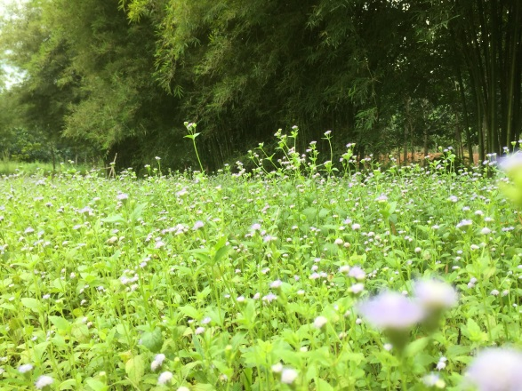

Figure ‎2.2 A Sample of Grass and Bamboo 2

Table ‎2.8 The Sample of the Table with More Than One Page Items

| No | Molecular Descriptors | Abbreviation | Groups | Amount | Description |
| --- | --- | --- | --- | --- | --- |
| 1 | Constitutional descriptors | Con | 0D | 48 | 0D-descriptors, independent from molecular connectivity and conformations. Atom and bonds counts, molecular weight, sum of atomic properties, etc |
| 2 | Topological descriptors | Topo | 2D | 119 | Molecular descriptors obtained from the molecular graph (usually H-depleted), i.e 2D-descriptors conformationally independent. |
| 3 | Walk and path  counts | Wap | 2D | 47 | Molecular descriptors obtained from the molecular graph, counting paths, walk and self returning walks of different lengths. |
| 4 | Connectivity  indices | Coni | 2D | 33 | Topological Molecular descriptors calculated from the vertex degree of the atoms in the H-depleted molecular graph. |
| 5 | Information  indices | Info | 2D | 47 | Molecular descriptors calculated as information content of molecules, based on the calculation of equivalences classes from the molecular graph. Among them, the indices of neighbourhood degree and edge multiplicity. |
| 6 | 2D  autocorrelations | 2D | 2D | 96 | Molecular descriptors calculated from the molecular graph by summing the products of atom weights of the terminal atoms of all the paths of the considered path length (the lag) |
| 7 | Edge adjacency indices | Edge | 2D | 107 | Topological Molecular descriptors derived from the edge adjacency matrix which encodes the connectivity between graph edges. |
| 8 | Burden  eigenvalues | Bur | 2D | 64 | Molecular descriptors contained from the positive and negative eigenvalues of the adjacency matrix, weighting the diagonal element with atom weight. |
| 9 | Topological  charge indices | Topoc | 2D | 21 | First 10 eigenvalues (absolute values) obtained from a corrected adjacency matrix. |
| 10 | Eigenvalue-based indices | EiG | 2D | 44 | Topological descriptors calculated by the eigenvalues of the square(usually symmetric) matrix representing a molecular graph. |
| 11 | Randic molecular profiles | Ran | 3D | 41 | Molecular descriptors derived from the distance distribution moments of the geometry matrix, defined as the average row sum of its entries raised at the k-th power, normalized by the factor k. |
| 12 | Geometrical descriptors | Geo | 3D | 74 | Different kinds of conformationally dependent descriptors based on the molecular geometry. Reliable values are obtained if reliable conformations were previously calculated. |
| 13 | RDF descriptors | RDF | 3D | 150 | Molecular descriptors obtained by radial basis functions centred on different interatomic distances (from 0.5A to 15.5A) |
| 14 | 3D-MoRSE descriptors | 3D | 3D | 160 | Molecular descriptors calculated by summing atom weights by different angular scattering function. |
| 15 | WHIM  descriptors | WHIM | 3D | 99 | Molecular descriptors obtained as statistical indices of the atom projected onto the 3 principal components obtained from weighted covariance matrices of the atomic coordinates. |
| 16 | GETAWAY descriptors | GATE | 3D | 197 | Descriptors calculated from the leverage matrix obtained by the centred atoic coordinates (molecular influences matrix,MIM). The first four descriptors are calculated as information content and connectivity indices. HATA and H descriptors are 3D-autocorrelation descriptors obtained from MIM; R and R+ descriptors obtained from the leverage. Geometry matrix. |
| 17 | Functional group counts | Funct | Others | 152 | Molecular descriptors based on the counting of chemical functional groups. They are calculated by knowing the molecular composition and atom connectivity. |
| 18 | Atom-centred fragments | Atom | Others | 120 | Molecular descriptors, based on the counting of 120 atom-centred fragments, as defined by Ghose-Crippen. Some fragments are undefined by the authors. They are calculated by knowing the molecular composition and atom connectivity. |
| 19 | Charged descriptors | charged | Others | 14 | Fourteen charge descriptors which are reliable only when charge are estimated by quantum molecular methods |

## Themes and styles also help keep your document coordinated.

###### When you click Design and choose a new Theme, the pictures, charts, and SmartArt graphics change to match your new theme.

###### When you apply styles, your headings change to match the new theme.

## You Can Collapse Parts Of The Document And Focus On The Text You Want.

If you need to stop reading before you reach the end, Word remembers where you left off - even on another device.

Video provides a powerful way to help you prove your point. When you click Online Video, you can paste in the embed code for the video you want to add. You can also type a keyword to search online for the video that best fits your document.

To make your document look professionally produced, Word provides header, footer, cover page, and text box designs that complement each other. For example, you can add a matching cover page, header, and sidebar. Click Insert and then choose the elements you want from the different galleries.

Themes and styles also help keep your document coordinated. When you click Design and choose a new Theme, the pictures, charts, and SmartArt graphics change to match your new theme. When you apply styles, your headings change to match the new theme.

Save time in Word with new buttons that show up where you need them. To change the way a picture fits in your document, click it and a button for layout options appears next to it. When you work on a table, click where you want to add a row or a column, and then click the plus sign.

#### Word remembers where you left off - even on another device.

Video provides a powerful way to help you prove your point.

When you click Online Video, you can paste in the embed code for the video you want to add.

You Can Also Type A Keyword To Search Online For The Video That Best Fits Your Document.

To Make Your Document Look Professionally Produced, Word Provides Header, Footer, Cover Page, And Text Box Designs That Complement Each Other.

For Example, You Can Add A Matching Cover Page, Header, And Sidebar.

Click Insert And Then Choose The Elements You Want From The Different Galleries.

Video provides a powerful way to help you prove your point. When you click Online Video, you can paste in the embed code for the video you want to add. You can also type a keyword to search online for the video that best fits your document. To make your document look professionally produced, Word provides header, footer, cover page, and text box designs that complement each other.

For example, you can add a matching cover page, header, and sidebar. Click Insert and then choose the elements you want from the different galleries. Themes and styles also help keep your document coordinated. When you click Design and choose a new Theme, the pictures, charts, and SmartArt graphics change to match your new theme.

When you apply styles, your headings change to match the new theme. Save time in Word with new buttons that show up where you need them. To change the way a picture fits in your document, click it and a button for layout options appears next to it. When you work on a table, click where you want to add a row or a column, and then click the plus sign.

Reading is easier, too, in the new Reading view. You can collapse parts of the document and focus on the text you want. If you need to stop reading before you reach the end, Word remembers where you left off - even on another device. Video provides a powerful way to help you prove your point.

When you click Online Video, you can paste in the embed code for the video you want to add. You can also type a keyword to search online for the video that best fits your document. To make your document look professionally produced, Word provides header, footer, cover page, and text box designs that complement each other. For example, you can add a matching cover page, header, and sidebar.

## Literature 2

When you apply styles, your headings change to match the new theme. Save time in Word with new buttons that show up where you need them. To change the way a picture fits in your document, click it and a button for layout options appears next to it. When you work on a table, click where you want to add a row or a column, and then click the plus sign.

Reading is easier, too, in the new Reading view. You can collapse parts of the document and focus on the text you want. If you need to stop reading before you reach the end, Word remembers where you left off - even on another device. Video provides a powerful way to help you prove your point.

#### Literature 3

When you apply styles, your headings change to match the new theme. Save time in Word with new buttons that show up where you need them. To change the way a picture fits in your document, click it and a button for layout options appears next to it. When you work on a table, click where you want to add a row or a column, and then click the plus sign.

Reading is easier, too, in the new Reading view. You can collapse parts of the document and focus on the text you want. If you need to stop reading before you reach the end, Word remembers where you left off - even on another device. Video provides a powerful way to help you prove your point.

#### Video provides a powerful way to help you prove your point.

When you apply styles, your headings change to match the new theme. Save time in Word with new buttons that show up where you need them. To change the way a picture fits in your document, click it and a button for layout options appears next to it. When you work on a table, click where you want to add a row or a column, and then click the plus sign.

Reading is easier, too, in the new Reading view. You can collapse parts of the document and focus on the text you want. If you need to stop reading before you reach the end, Word remembers where you left off - even on another device. Video provides a powerful way to help you prove your point.

##### When you click Online Video, you can paste in the embed code for the video you want to add.

##### You can also type a keyword to search online for the video that best fits your document.

##### To make your document look professionally produced, Word provides header, footer, cover page, and text box designs that complement each other.

# METHODOLOGY

## Introduction

This chapter describes the methods, techniques and any validation of methods used in the study. This may include section(s) that describe the methodology in detail, the theoretical development, the hypothesis description, the fundamental philosophical foundation, the experimental design and the standard procedure description. For studies in the social sciences, a theoretical or conceptual framework should also be included. Published protocols or methods must be cited with references.

## Video Provides A Powerful Way To Help You Prove Your Point.

#### When you click Online Video, you can paste in the embed code for the video you want to add.

#### You can also type a keyword to search online for the video that best fits your document.

##### To make your document look professionally produced, Word provides header, footer, cover page, and text box designs that complement each other.

##### For example, you can add a matching cover page, header, and sidebar.

#### Click Insert and then choose the elements you want from the different galleries.

Video provides a powerful way to help you prove your point. When you click Online Video, you can paste in the embed code for the video you want to add. You can also type a keyword to search online for the video that best fits your document.

To make your document look professionally produced, Word provides header, footer, cover page, and text box designs that complement each other. For example, you can add a matching cover page, header, and sidebar. Click Insert and then choose the elements you want from the different galleries.

Themes and styles also help keep your document coordinated. When you click Design and choose a new Theme, the pictures, charts, and SmartArt graphics change to match your new theme. When you apply styles, your headings change to match the new theme.

To change the overall look of your document, choose new Theme elements on the Page Layout tab. To change the looks available in the Quick Style gallery, use the Change Current Quick Style Set command. Both the Themes gallery and the Quick Styles gallery provide reset commands so that you can always restore the look of your document to the original contained in your current template.

## MZJ Formatting Method



Figure ‎3.1 A Sample of Formatting Method



Figure ‎3.2 The Hadith on Knowledge

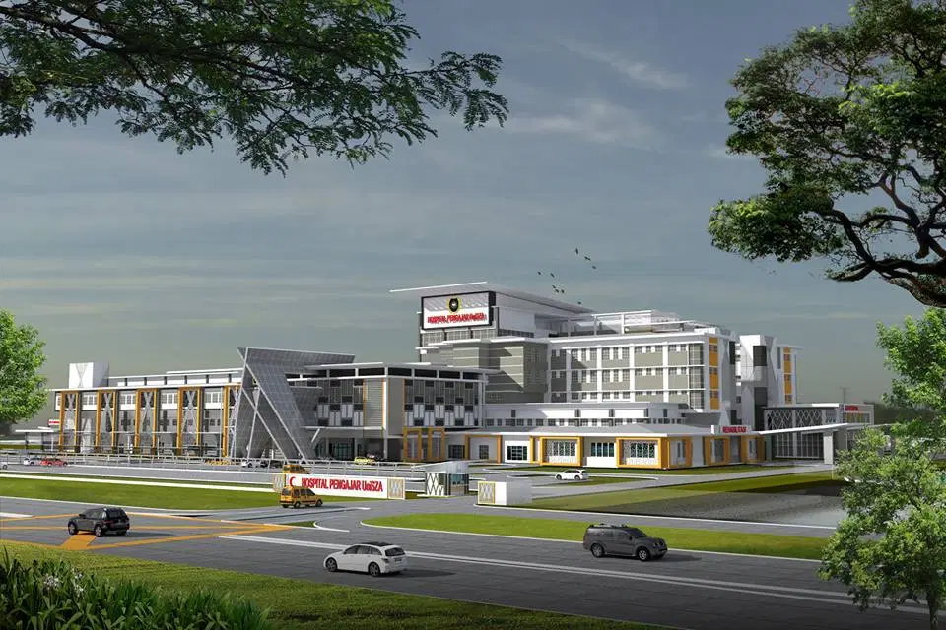

Figure ‎3.3 Landscape of the Hospital (SA, 2020)

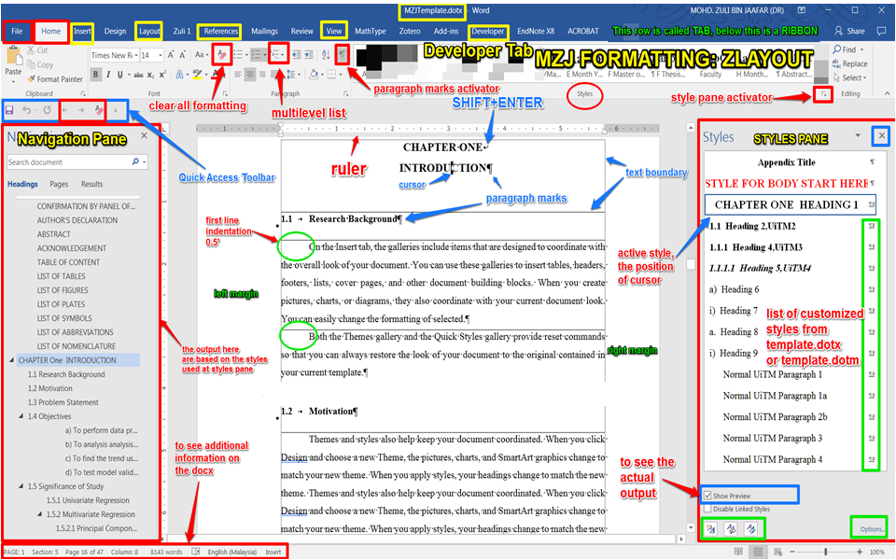

Figure ‎3.4 The screen for formatting a thesis using MS Word (MZJ, 2017)

# RESULTS

## Introduction

This chapter presents a complete account of the results and analyses of the study in the form of figures, tables or texts, highlighting key information. Results and Discussion may be written in more than one chapter depending on the number of experimental works and / or parametric studies conducted. In such cases, each chapter on results should contain a discussion.

## You Can Collapse Parts Of The Document And Focus On The Text You Want.

If you need to stop reading before you reach the end, Word remembers where you left off - even on another device.

Table ‎4.1 Average rainfall in 2020.

|  |  |  |  |  |
| --- | --- | --- | --- | --- |
| Variable | Minimum | Maximum | Average | Standard deviation |
| Average relative humidity (%) | 31.0 | 97.0 | 63.70 | 14.80 |
| Average pressure (hPa) | 994.37 | 1022.43 | 1009.04 | 6.48 |
| Average wind speed (Knot) | 0.0 | 9.0 | 0.79 | 1.43 |
| Average rainfall (mm) | 0.0 | 140.0 | 3.82 | 14.05 |

Source: Caption for source is here

Video provides a powerful way to help you prove your point. When you click Online Video, you can paste in the embed code for the video you want to add. You can also type a keyword to search online for the video that best fits your document

#### To make your document look professionally produced, Word provides header, footer, cover page, and text box designs that complement each other. For example, you can add a matching cover page, header, and sidebar. Click Insert and then choose the elements you want from the different galleries.

Themes and styles also help keep your document coordinated. When you click Design and choose a new Theme, the pictures, charts, and SmartArt graphics change to match your new theme. When you apply styles, your headings change to match the new theme.

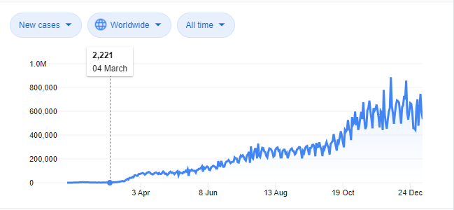

Figure ‎4.1 Number of Covid-19 cases.

Save time in Word with new buttons that show up where you need them. To change the way a picture fits in your document, click it and a button for layout options appears next to it. When you work on a table, click where you want to add a row or a column, and then click the plus sign.

#### Reading is easier, too, in the new Reading view. You can collapse parts of the document and focus on the text you want. If you need to stop reading before you reach the end, Word remembers where you left off - even on another device.

Video provides a powerful way to help you prove your point.

When you click Online Video, you can paste in the embed code for the video you want to add.

# DISCUSSION

## Introduction

This chapter discusses the results of the study in relation to the hypothesis / conceptual theory / research questions of the study. It highlights the main findings, their significance and implications. The discussion should fit into the existing or current body of knowledge.

#### Discussion based on objective number 1

Video provides a powerful way to help you prove your point. When you click Online Video, you can paste in the embed code for the video you want to add. You can also type a keyword to search online for the video that best fits your document.

To make your document look professionally produced, Word provides header, footer, cover page, and text box designs that complement each other. For example, you can add a matching cover page, header, and sidebar. Click Insert and then choose the elements you want from the different galleries.

Themes and styles also help keep your document coordinated. When you click Design and choose a new Theme, the pictures, charts, and SmartArt graphics change to match your new theme. When you apply styles, your headings change to match the new theme.

Save time in Word with new buttons that show up where you need them. To change the way a picture fits in your document, click it and a button for layout options appears next to it. When you work on a table, click where you want to add a row or a column, and then click the plus sign.

Reading is easier, too, in the new Reading view. You can collapse parts of the document and focus on the text you want. If you need to stop reading before you reach the end, Word remembers where you left off - even on another device.

Table ‎5.1 Humidity and wind speed in 2020.

|  |  |  |  |  |
| --- | --- | --- | --- | --- |
| Variable | Minimum | Maximum | Average | Standard deviation |
| Average relative humidity (%) | 31.0 | 97.0 | 63.70 | 14.80 |
| Average pressure (hPa) | 994.37 | 1022.43 | 1009.04 | 6.48 |
| Average wind speed (Knot) | 0.0 | 9.0 | 0.79 | 1.43 |
| Average rainfall (mm) | 0.0 | 140.0 | 3.82 | 14.05 |

#### Discussion based on objective number 2

you can paste in the embed code for the video you want to add. You can also type a keyword to search online for the video that best fits your document.

To make your document look professionally produced, Word provides header, footer, cover page, and text box designs that complement each other. For example, you can add a matching cover page, header, and sidebar. Click Insert and then choose the elements you want from the different galleries.

Themes and styles also help keep your document coordinated. When you click Design and choose a new Theme, the pictures, charts, and SmartArt graphics change to match your new theme. When you apply styles, your headings change to match the new theme.

Save time in Word with new buttons that show up where you need them. To change the way a picture fits in your document, click it and a button for layout options appears next to it. When you work on a table, click where you want to add a row or a column, and then click the plus sign.

Reading is easier, too, in the new Reading view. You can collapse parts of the document and focus on the text you want

#### Discussion based on objective number 3

you can paste in the embed code for the video you want to add. You can also type a keyword to search online for the video that best fits your document.

To make your document look professionally produced, Word provides header, footer, cover page, and text box designs that complement each other. For example, you can add a matching cover page, header, and sidebar. Click Insert and then choose the elements you want from the different galleries.

Themes and styles also help keep your document coordinated. When you click Design and choose a new Theme, the pictures, charts, and SmartArt graphics change to match your new theme. When you apply styles, your headings change to match the new theme.

Save time in Word with new buttons that show up where you need them. To change the way a picture fits in your document, click it and a button for layout options appears next to it. When you work on a table, click where you want to add a row or a column, and then click the plus sign.

## Reading is easier, too, in the new Reading view. You can collapse parts of the document and focus on the text you want

Below is the information of the Covid-10 cases

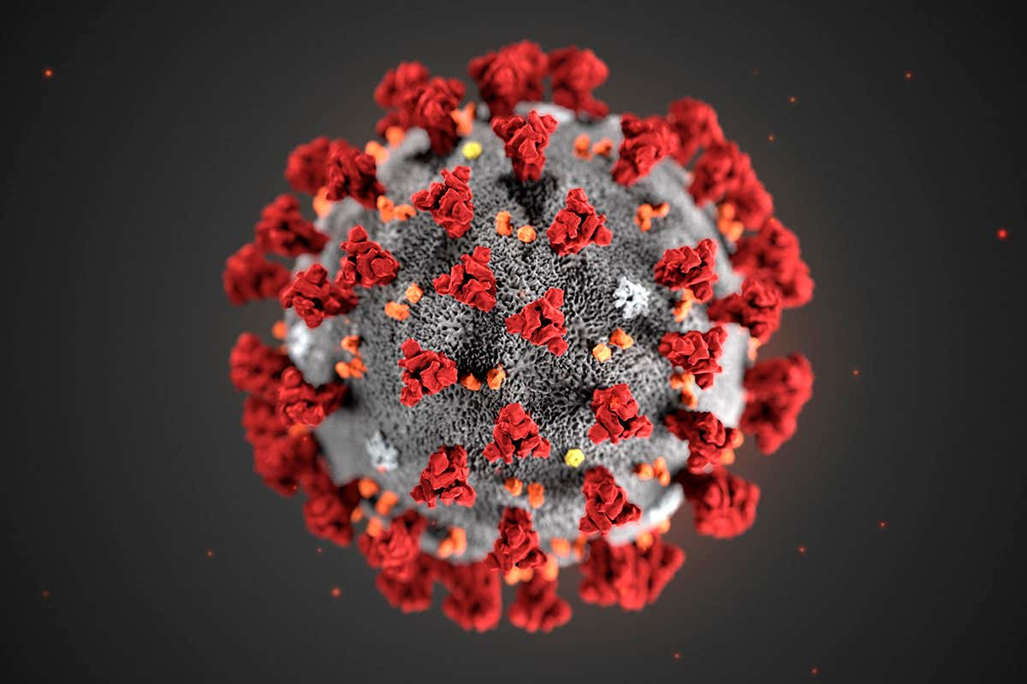

Figure ‎5.1 Covid-19 virus.

## Themes And Styles Also Help Keep Your Document Coordinated.

#### When you click Design and choose a new Theme, the pictures, charts, and SmartArt graphics change to match your new theme.

#### When you apply styles, your headings change to match the new theme.

## Save time in Word with new buttons that show up where you need them.

## To change the way a picture fits in your document, click it and a button for layout options appears next to it.

When you work on a table, click where you want to add a row or a column, and then click the plus sign.

|  |  |  |
| --- | --- | --- |
|  |  |  |
| 1. Pre-process data: A1, R1 and C1 | 1. Pre-process data: A1, R1 and C2 | 1. Pre-process data: A1, R1, C3 |
|  |  |  |
| 1. Pre-process data: A1, R2 and C1 | 1. Pre-process data: A1, R2 and C2 | 1. Pre-process data: A1, R2, C3 |

Figure ‎5.2 A PCA Plots for Data Processing Strategy

Video provides a powerful way to help you prove your point. When you click Online Video, you can paste in the embed code for the video you want to add. You can also type a keyword to search online for the video that best fits your document. To make your document look professionally produced, Word provides header, footer, cover page, and text box designs that complement each other. For example, you can add a matching cover page, header, and sidebar. Click Insert and then choose the elements you want from the different galleries.

Themes and styles also help keep your document coordinated. When you click Design and choose a new Theme, the pictures, charts, and SmartArt graphics change to match your new theme. When you apply styles, your headings change to match the new theme. Save time in Word with new buttons that show up where you need them. To change the way a picture fits in your document, click it and a button for layout options appears next to it. When you work on a table, click where you want to add a row or a column, and then click the plus sign.

Reading is easier, too, in the new Reading view. You can collapse parts of the document and focus on the text you want. If you need to stop reading before you reach the end, Word remembers where you left off - even on another device.

.

# CONCLUSION

## Introduction

This chapter highlights the summary of the study’s findings upon which a conclusion is drawn, reiterating and discussing the objectives set at the beginning of the study. It also consists of the implications, limitations and recommendations for future research.

## Highlight term 1

Video provides a powerful way to help you prove your point. When you click Online Video, you can paste in the embed code for the video you want to add. You can also type a keyword to search online for the video that best fits your document.

To make your document look professionally produced, Word provides header, footer, cover page, and text box designs that complement each other. For example, you can add a matching cover page, header, and sidebar. Click Insert and then choose the elements you want from the different galleries.

## Highlight term 2

Themes and styles also help keep your document coordinated. When you click Design and choose a new Theme, the pictures, charts, and SmartArt graphics change to match your new theme. When you apply styles, your headings change to match the new theme.

Save time in Word with new buttons that show up where you need them. To change the way a picture fits in your document, click it and a button for layout options appears next to it. When you work on a table, click where you want to add a row or a column, and then click the plus sign.

Reading is easier, too, in the new Reading view. You can collapse parts of the document and focus on the text you want. If you need to stop reading before you reach the end, Word remembers where you left off - even on another device.

## Highlight term 3

Themes and styles also help keep your document coordinated. When you click Design and choose a new Theme, the pictures, charts, and SmartArt graphics change to match your new theme. When you apply styles, your headings change to match the new theme.

Save time in Word with new buttons that show up where you need them. To change the way a picture fits in your document, click it and a button for layout options appears next to it. When you work on a table, click where you want to add a row or a column, and then click the plus sign.

Reading is easier, too, in the new Reading view. You can collapse parts of the document and focus on the text you want. If you need to stop reading before you reach the end, Word remembers where you left off - even on another device.

## Conclusion

Themes and styles also help keep your document coordinated. When you click Design and choose a new Theme, the pictures, charts, and SmartArt graphics change to match your new theme. When you apply styles, your headings change to match the new theme.

Save time in Word with new buttons that show up where you need them. To change the way a picture fits in your document, click it and a button for layout options appears next to it. When you work on a table, click where you want to add a row or a column, and then click the plus sign.

Reading is easier, too, in the new Reading view. You can collapse parts of the document and focus on the text you want. If you need to stop reading before you reach the end, Word remembers where you left off - even on another device.

REFERENCES

Baniya, S., & Weech, S. (2019). Data and experience design: Negotiating community-oriented digital research with service-learning. *Purdue Journal of Service-Learning and International Engagement, 6*(1), 11–16.

Denny, H., Nordlof, J., & Salem, L. (2018). Understanding the needs and expectations of working-class students in writing centers. *Writing Center Journal, 37*(1), 67–98. [https://doi.org/10.5703/1288284316979](https://doi.org/10.5703/1288284316979?_ga=2.122211211.1061800417.1613459094-833073771.1613459094)

Moore, W. K. (2004). *Malaysia: A Pictorial History 1400-2004*. Kuala Lumpur: Archipelago Press.

Wilkins F. G. *Structure of Compounds.* Paper presented at the meeting of the Canadian Chemical Association, Ontario. June 2005.

HealthTimes. (2015). The future of aged care nursing in Australia. Retrieved from <https://healthtimes.com.au/hub/aged-care/2/news/nc1/the-future-of-aged-care-nursing-in-australia/495/>

Yusof, Y., Ibrahim, Y, M., & Coyne, R.P. (2017). *A guide to citation*. London, England: My Publisher.

Othman, A. S., Marin-Mogollon, C., Salman, A. M., Franke-Fayard, B. M., Janse, C. J., & Khan, S. M. (2017). The use of transgenic parasites in malaria vaccine research. *Expert Review of Vaccines, 16*(7), 685-697. doi:10.1080/14760584.2017.1333426.

APPENDICES

Appendix A Example of the Codes in PLS Algorithms

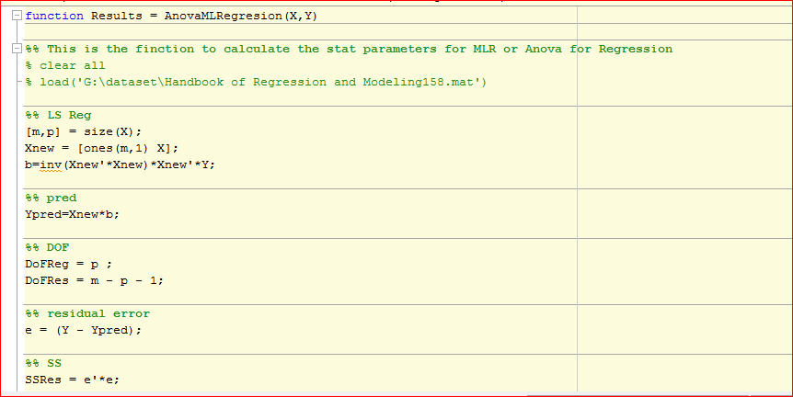

Appendix B Table of Parameters Used in Data Processing for PLS Testing Precoders on the Classification of Biological Activity

|  |  |  |
| --- | --- | --- |
| Type | Formula | Description |
| C1 |  | Mean centring |
| C2 |  | Standardisation |
| C3 |  | Range scaling |

Appendix C Table of Parameters

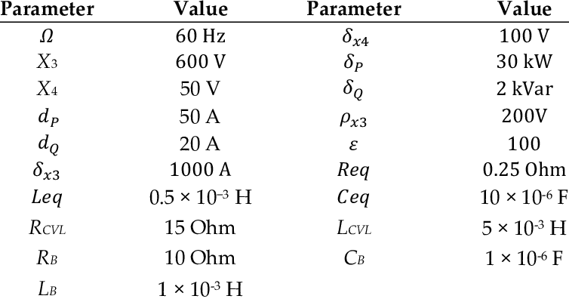

LIST OF PUBLICATION(S)

Yusof, Y., Ibrahim, Y, M., & Coyne, R.P. (2019). The implementation of green practices in the Malaysian hotel industry. *The Asian Symposium on Sustainable Tourism for Development, 6*(1), 11-16. <https://doi.org/10.5703/129944316979>

Yusof, Y., Ibrahim, Y, M., & Coyne, R.P. (2018). The influence of a green image and customer satisfaction towards customer loyalty in the hotel industry. *International Journal of Green Economics, 11*(1), 1–14. <https://www.ijge.org/stable/262163>

Yusof, Y., Ibrahim, Y, M., & Coyne, R.P. (2017). *A guide to citation*. London, England: My Publisher.

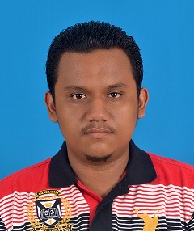CANDIDATE BIODATA

Safwan bin Othman was born 28 December 1985 in Kuala Terengganu, Terengganu. He received his early education at Sekolah Kebangsaan Gong Badak and Sekolah Tok Jiring, Setiu. Then he continued his education at Kolej Sains Pendidikan Islam Negeri Terengganu (KOSPINT), Kuala Terengganu until form five. He continued his studies at the Kedah Matriculation College, Changlun before pursuing a Bachelor of Hospital Development at Universiti Malaysia Kelantan in 2004. After completing the study in 2007, he served in Khalifah Education and Training Institute, Paka as Students Affairs Officer until the end of 2008. In 2009, he served in Pusat Tahfiz Gemilang, Kuala Terengganu as Human Resources Officer until 2010 before continuing his studies at the Master level in the field of Hospital Management at Universiti Malaysia Terengganu, Kuala Terengganu. Starting October 2014, he started his PhD studies at Universiti Sultan Zainal Abidin in the field of Hospital Management under the supervision of Prof. Dr. Shafie bin Bakhtiar and Prof. Dr. Imran bin Ajmain. His research interest is on environmental management; green initiatives; sustainability; hospital management; and consumer behavior in hospital industry.

white

1. Ahmad Kadri Junoh et al., “Smart Surveillance System Detection Using PCA- Based Feature Extraction” *Applied Mechanics and Materials*. 232 (2012): 137–141.
2. Faizir Ramlie et al., “A Significant Feature Selection in the Mahalanobis Taguchi System using Modified-Bees Algorithm” *International Journal of Engineering Research and Technology*. 13.1 (2020): 117–136.
3. Wan Zuki Azman Wan Muhamad et al., “Combination of feature selection approaches with random binary search and Mahalanobis Taguchi System in credit scoring” *AIP Conference Proceedings*. 1974.1 (2018): 20004.